Practical 11
Aim
To use JavaScript timers (setTimeout() and setInterval()) and ES6 modules (import/export) to build a dynamic class scheduler with real-time updates and a responsive layout.
Software Required
- Visual Studio Code (or any code editor)
- Live Server extension for VS Code (ES modules must be served over http://)
- Web browser with ES module support and Developer Tools (Google Chrome / Microsoft Edge / Mozilla Firefox)
- Basic knowledge of HTML, CSS and JavaScript
Theory
Timers let a script run code later or repeatedly without freezing the page. setTimeout(function, delay) runs the function once after the given number of milliseconds, while setInterval(function, interval) runs it again and again at that interval. Each returns an ID that is passed to clearTimeout() or clearInterval() to cancel it. Timer callbacks are asynchronous: they wait in a queue until the event loop is free, so the delay is a minimum rather than an exact guarantee, and browsers may slow timers in background tabs. For this reason a clock or countdown should not simply subtract one second per tick; instead, the remaining time is recalculated from the real current time on every tick (target time minus current time), which prevents drift.
Feature | setTimeout() | setInterval()
Runs | Once, after the delay | Repeatedly, every interval
Cancelled with | clearTimeout(id) | clearInterval(id)
Typical use | Reminders, auto-hiding messages | Clocks, countdowns, live refresh
Used in this practical | Reminder alert; toast auto-dismiss | One-second tick that refreshes the page

A countdown is displayed by converting the remaining milliseconds into days, hours, minutes and seconds using division and the modulo operator, padding each part to two digits, and writing the text into the page with textContent on every tick. Because the DOM is updated each second, the interface changes in real time without any reload.
ES6 modules are the standard way to divide a program into separate, reusable files. A file shares values with the export keyword: named exports (export const x, export function f) are imported by name inside braces, import { x, f } from ‘./file.js’, while a file may have one default export, imported under any name, import config from ‘./data.js’. A page loads its entry module with <script type="module">. Modules run in strict mode, are deferred until the page is parsed, keep their top-level variables private unless exported, and execute only once even when imported by several files. Since browsers fetch modules with HTTP requests, they must be served from a web server such as Live Server and cannot be opened directly from file://. Splitting code this way separates concerns, avoids global variables, and makes each part easier to test and reuse.
A responsive layout adapts to the screen size. This is achieved with CSS Grid and Flexbox, relative units and the clamp() function for fluid text sizes, the viewport meta tag, and media queries that change the layout at breakpoints — for example one column on a phone and two columns on a wide screen.
Implementation Overview
A Class Scheduler was built from six ES modules, each with a single responsibility:
Module | Responsibility
data.js | Timetable and settings. Named exports: DAYS, SCHEDULE. Default export: config.
clock.js | now() returns the real time, or an accelerated demo time used for testing.
scheduler.js | Pure logic: which class is running, which is next, and each class's status.
timers.js | createTicker() (setInterval/clearInterval), after() (setTimeout) and formatCountdown().
ui.js | All DOM updates: clock, countdown card, timetable list, day tabs and notifications.
main.js | Entry point: imports every module, runs the one-second tick and handles the buttons.

The page shows a live clock and a countdown card. While a class is running, the card shows the subject, the time remaining and a progress bar; between classes it counts down to the next class, even across days (for example, from Sunday to Monday morning). A timetable with day tabs lists each class with a status that changes from upcoming to ongoing to completed as time passes. A one-second setInterval() drives all updates, and the ‘Pause updates’ button stops it with clearInterval(). The ‘Remind me’ button uses setTimeout() to show an alert a few minutes before the next class, and notifications disappear automatically through setTimeout(). A demo clock runs time 60 times faster so that class changes can be observed within a minute. The layout is single-column on phones and two-column on wider screens.
Output
File Path - D:\Symbiosis University\Sem 5\JavaScript\JavaScript VSCode\Practical 11\index.html
24070521271_SnehaShah

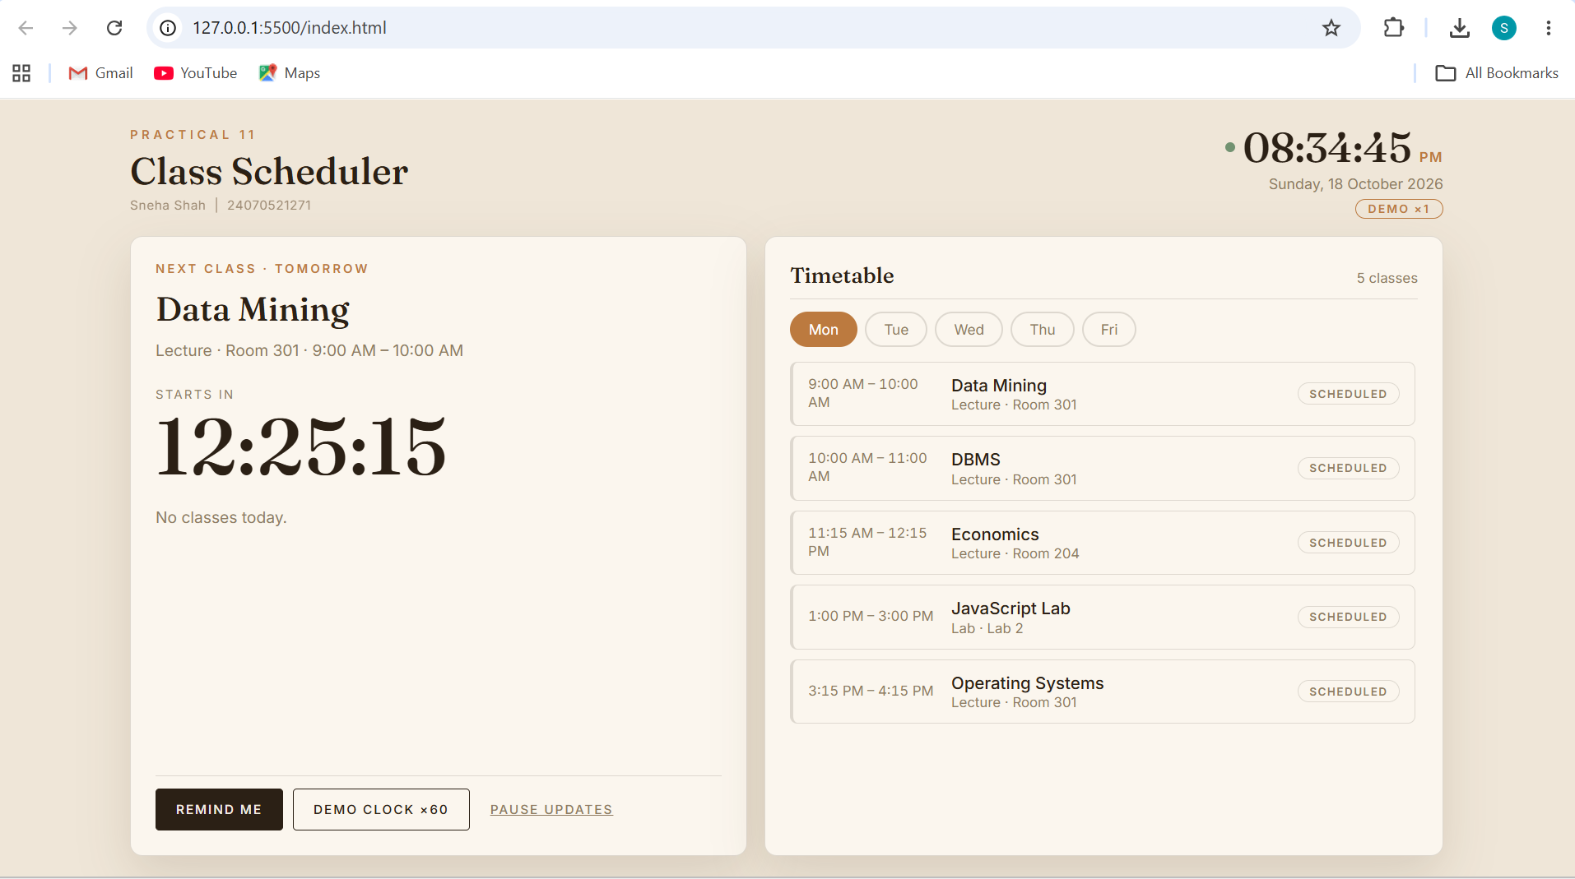
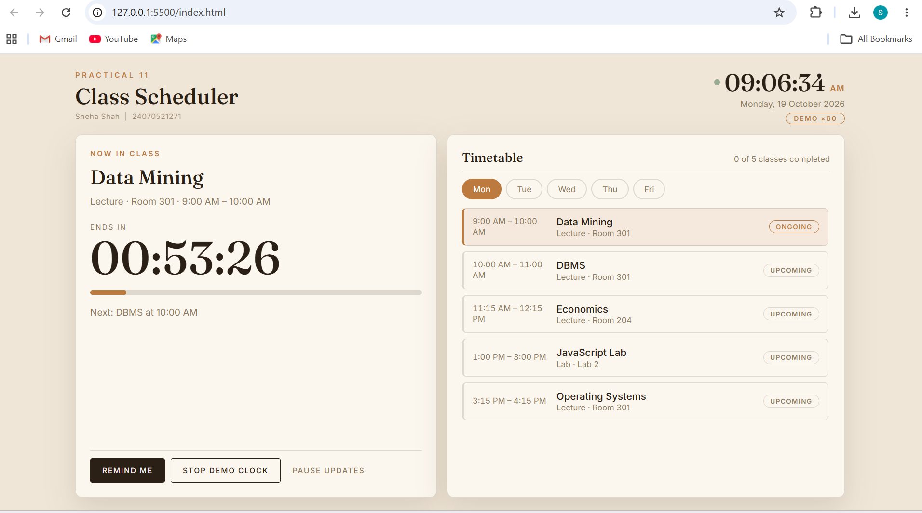
Result
The class scheduler ran successfully through Live Server. The clock and countdown updated every second, the timetable statuses and the progress bar changed automatically as classes began and ended, and the reminder and class-start notifications appeared at the correct moments and disappeared on their own. Pausing the updates froze the display and resuming restarted it. The demo clock allowed the full cycle of upcoming, ongoing and completed classes to be observed in a short time. The six modules loaded correctly in the Network tab, and the layout rearranged itself from two columns to one when the window was narrowed to a mobile width.

